s

Software requirement specification

(SRS) document template

***Project name*:** *ReadEase: An Online Book Shopping Platform*

***Date*:**24/3/2025

***Version***: latest version

***Doctor’s name***: doctor Ibrahim Dhaini

***Team members:***

* Malak Abadi (id=1322011)
* Ghadir msayleb (id=1122242)

|  |  |  |  |  |
| --- | --- | --- | --- | --- |
|  | Revision history |  |  | |
| Version | Author | Version Description | Date completed | |
| 1.0 | -Malak abadi  -Ghadir msayleb | The initial draft of SRS | 23/3/2025 | |
| Review History |  |  |  |
| Approving party | Version approved | Signature | Date |
| Dr. Ibrahim Dhaini | 1.0 | Not Available | 23/3/2025 |

|  |  |  |  |
| --- | --- | --- | --- |
| Approval History |  |  |  |
| Reviewer | Version reviewed | Signature | Date |
| Malak abadi  -Ghadir msayleb | 1.0 | Not Available | 23/3/2025 |

------------------------------------------------------------

|  |
| --- |
| Table of content  1)introduction  1.1 Product scope  1.2 Product Value  1.3 Intended audience  1.4 Intended use  1.5 General description  2)Functional requirements  3)External interface requirements  3.1 User interface requirements  3.2 Hardware interface requirements  3.3 Software interface requirements  3.4 Communication interface requirements  4) Non-functional requirements  4.1 Security  4.2 Capacity  4.3 Compatibility  4.4 Reliability  4.5 Scalability  4.6 Maintainability  4.7 Usability  4.8 Other non-functional requirements  5) Definitions and acronyms  1)introduction  **This Software Requirements Specification (SRS) document describes the website's functional and non-functional requirements, system features, and user expectations. It also serves as a roadmap for developers and stakeholders to ensure a shared understanding of the system’s objectives, scope, and design.**  1.1)product scope : Benefits:*1. The user can shop anywhere and anytime.* *2. The user has access to Different types of books.*  *3. The user enjoys a safe and* Secure exchange *process*. Objectives: *1. Ensure the user has a User-friendly interface and fast checkout.*  *2. Protect the user’s data and payments.*  *3. Provide the user with a responsive design on all devices(mobiles, screens,pc, iPads…)*  ***Goal of the project***  1. Capture the user’s attention through special offers and recommendations.  2. Encouraging customers to buy again due to discounts depending on several orders registered on the system.  3. Reach more users and attract users worldwide.  1.2) product value  1.*.****Convenience***: Shop anytime, anywhere, without visiting a store.  2. ***Wide Selection***: Browse a variety of books across all categories and types  3. ***Personalized Recommendations***: Discover books personalized to the user’s taste  4. ***Secure Payments***: Safely complete transactions with trusted payment methods.  5. ***Quick Delivery***: deliver books quickly and securely  6. ***User-Friendly Experience***: Easy browsing, easy shopping  1.3 )Intended audience  1. *Students*  *2. Professionals*  *3. Gift Seekers*  *4. Casual Shoppers*  *5. Global Audiences*  *6.* *Book Lovers*  1.4) Intended use  *1. Browsing: Users will explore various book categories, types, and recommendations to find books that are interesting in them.*  *2. Searching: Customers will use search filters to find specific titles, authors, or categories.*  *3. Purchasing: Users will add books to their cart, proceed to checkout, and complete secure payment transactions.*  *4.* ***Account Management****: Users will create accounts to track orders, maintain preferences, and track order history*  1.5 General description  **This system will provide a smooth, consistent, and secure shopping experience since it will allow users to register and manage their accounts, browse and search for books using filters, and securely purchase items through a simple checkout process. Moreover, Users can track orders, receive book recommendations, and access customer support through FAQs and live chat.**  2)Functional requirements  • **User Registration and Login**:  Users must be able to create accounts, log in, and reset passwords.  • **Book Search and Filters**:  Users can search for books by title, author, type, category, and other filters.  • **Book Details**:  Each book must have a detailed page with information such as title, author, price, description, and reviews and details  • **Shopping Cart**:  Users can add, remove, and update books in their cart before clicking on checkout  • **Secure Payment Gateway**:  The system must support multiple payment methods (credit card, PayPal) with secure procedures  • **Order Confirmation and Tracking**:  After purchase, users must receive an order confirmation and be able to track delivery status.  • **User Reviews and Ratings**:  Users can submit reviews and ratings for books after purchasing them  • **Recommendation System**:  Personalized book recommendations based on user preferences and purchase history.  • **Customer Support**:  Users should have access to FAQs, live chat, or email support for assistance.  • **Admin Dashboard**:  Admins can manage products (books), view orders, and update book details.  3)External interface requirements  3.1 User Interface Requirements:   * The website should be user-friendly and not require much effort to understand how to use it. * Users should be able to browse books easily with well-organized categories and search filters. * The website should feature a responsive design across different types of devices like mobile phones, tablets, desktops… * A secure and simple account management system should be available for tracking orders and Keeping user choices   3.2 Hardware Interface Requirements   * The system must be accessible on various hardware platforms, including smartphones, tablets, laptops, and desktops. * Payment system should be compatible with card readers for future expansion into physical stores (if applicable)   3.3 Software Interface Requirements   * The system should integrate with a **secure payment gateway** (e.g., PayPal, Stripe) to process transactions safely.   • The website should connect with a product management system to update book availability in real-time.  • An email notification system should be in place to send order confirmations, sales, discounts, and updates.   **3.4 Communication Interface Requirements** *• The system must use HTTPS encryption to ensure secure data transmission.*  *• Users ought to receive real-time notifications via email or SMS about order updates and special promotions.*  -----------------------------------------------------------------------------------------------------------------------------------------  4) Non-functional requirements  4.1) Security:  Privacy & Data Protection Regulations   * *GDPR*: Data protection for EU users. * *CCPA*: Data control for California users. * *PCI-DSS*: Secure handling of payment info.   4.2) Capacity:  Storage Needs :   * *Current*: Support for up to 10,000 product(books) listings and 1 million user records. * *Future*: Scalable to handle increased product(books) inventory and growing user base.   4.3 )Compatibility  The minimum hardware requirements:   * *Processor*: Dual-core CPU (2.5 GHz or higher) * *RAM*: 4 GB (8 GB recommended) * *Storage*: 50 GB of free disk space (SSD recommended) * *Network*: Stable internet connection (Broadband or higher) * *Display*: 1366x768 resolution or higher   4.4) Reliability  *Critical Failure Time (CFT)*   * *Critical Failure Time*: The product should be able to handle up to 99.9% uptime, meaning the critical failure time should not exceed 43 minutes per month (allowing for scheduled maintenance and unexpected downtime). * *Normal Usage*: In case of failure, recovery should happen within 1 hour to ensure minimal disruption to users.   4.5) Scalability  *Highest Workloads*   * *Maximum Concurrent Users*: The system should handle up to 5,000 simultaneous users without performance falling * *Product Listings*: The website should support up to 1 million book listings while maintaining fast search and filter performance. * *Transactions per Minute*: The system should be able to process 500 transactions per minute during peak load times.   4.6 ) Maintainability  *Continuous Integration for Quick Deployment*   * *Automated Testing*: Use automated unit and integration tests to catch bugs early. * *Version Control*: Use Git for version control to manage code changes and enable collaboration.   • *Frequent Deployments*: Deploy new features and bug fixes *multiple times a day* with minimal downtime.    4.8) Other:  ***Performance:*** The website should load within **3 seconds** even under heavy traffic  5) Definitions and acronyms **Definitions:** **ReadEase: An Online Book Shopping Platform**: ReadEase is an e-commerce website designed for book lovers, offering a wide selection of books, personalized recommendations, and a seamless online shopping experience.  **Books**: A collection of literary works, including but not limited to physical books, e-books, and audiobooks, available for purchase or download through the ReadEase platform  **Admin**: A system user with elevated privileges responsible for managing and overseeing the ReadEase platform  **User**: An individual who interacts with the ReadEase platform to browse, search, purchase, and manage their book orders.  **User Account**: An account created by a user on the website to track orders, manage preferences, and store personal information.  ***Payment Gateway****:* A service that processes credit card payments for online purchases, such as PayPal, Stripe, etc.  ***Recommendation System***: A system that provides personalized suggestions to users based on their browsing and purchase history.  ***Order Confirmation***: A notification sent to the user after completing a purchase, which confirms the order information and status.  ***GDPR (General Data Protection Regulation*)**: A regulation in EU law on data protection and privacy for all individuals within the European Union.  ***CCPA (California Consumer Privacy Act)****:* A state statute intended to enhance privacy rights and consumer protection for residents of California, USA.  ***PCI-DSS (Payment Card Industry Data Security Standard)****:* A set of security standards designed to ensure that all companies that accept, process, store, or transmit credit card information maintain a secure environment.  ***CI/CD Pipeline***: Continuous Integration and Continuous Deployment pipeline used to automate testing and deployment processes.  ***Critical Failure Time (CFT)****:* The time window in which critical failures can occur before affecting system uptime, typically measured as a percentage of total time.  ***Rollback Strategy****:* A mechanism to revert the system to its previous stable state in case of a failure during deployment or updates.  acronym  **HTTPS**: HyperText Transfer Protocol Secure, used for secure communication over a computer network.  **API**: Application Programming Interface, a set of protocols and tools that allows different software applications to communicate with each other.  **UI**: User Interface, the space where interactions between humans and machines occur.  **UX**: User Experience, how a user interacts with and experiences a system or product.  **SSD**: Solid State Drive, a type of storage device that uses flash memory to store data.  **RAM**: Random Access Memory, the computer memory used to store data temporarily for quick access by the CPU.  **SSL**: Secure Sockets Layer, a standard security technology for establishing an encrypted link between a web server and a browser.  **HTTP**: HyperText Transfer Protocol, the protocol used for transferring web pages.  **SDLC model: iterative model-incremental model**    The **Iterative Model with Agile Practices** is ideal for the ReadEase e-commerce website because it allows for:   * *Flexibility* to adapt to changing requirements and user feedback. * *Faster time-to-market,* earlier. delivering key features * *Continuous improvement* based on regular user input. * *Risk mitigation* by identifying and addressing issues early. * *Enhanced collaboration* among stakeholders, ensuring alignment with business goals. * *Scalability*, supporting future enhancements as user needs and requirements grow. * *Consistent quality* through continuous testing and integration.   This model ensures the platform evolves with user needs, maintains high quality, and stays competitive.  feasibility study   * 1. **Technical Feasibility**   -The proposed **ReadEase** platform can be implemented using existing **web development technologies** and **e-commerce frameworks**, ensuring compatibility with modern infrastructure.  - The platform can be built using **HTML, CSS, JavaScript (React, Vue, or Angular) for frontend** and **Node.js, Django, or Laravel for backend**, which are widely available technologies.  **-Database management** can be handled by **MySQL, PostgreSQL, or MongoDB**, ensuring efficient data storage and retrieval.  - The availability of **cloud hosting services** like AWS, Firebase, or DigitalOcean ensures scalability and smooth performance.  **-Necessary technical expertise** is available, as these technologies are well-documented and commonly used in the software industry.  **2. operational feasibility**  -Ensures smooth integration with existing systems.  -Minimizes disruptions to daily operations.  -Requires minimal training for adaptation.  -Enhances efficiency and customer experience  **3. legal feasibility**  -Ensures compliance with laws and ethics.  -Checks intellectual property and licensing.  -Adheres to industry regulations and standards.  **4. scheduling feasibility**  • **Estimated Timeline**:  **-1-2 months**: Research and planning.  **-3-6 months**: Website development and testing.  **-7-8 months**: Beta launch and feedback implementation.  **-9-12 months**: Full-scale launch and marketing.  **-Challenges**: Delays in development, testing, and obtaining approvals from legal authorities.  **5. Market Feasibility**   * **Target Audience**: Students, book lovers, and professionals looking for academic or leisure reading. * **Competition**: Competing with platforms like Amazon, local bookstores, and other online retailers. * **Marketing Strategy**: Social media marketing, influencer promotions, and email marketing. * **Challenges**: Attracting and retaining customers in a competitive market.   **6. Economic Feasibility**   * **Development Costs**: Includes hosting, domain, software development, and maintenance. * **Revenue Model**: Profits from book sales, affiliate marketing, or premium membership options. * **Break-even Analysis**: Estimating how long it will take to cover development costs and start making profits. * **Challenges**: Initial investment in marketing and maintaining a competitive pricing strategy. |

Phase two :

**The system must allow users to register, log in, and manage their accounts. Users can browse various book categories, search for specific titles or authors using filters, and view detailed information about each book. They can add books to a shopping cart, proceed to a secure checkout, and complete transactions using multiple payment methods. Registered users will be able to track their orders, submit reviews, and receive personalized book recommendations. In addition, the system provides customer support through live chat and FAQs. An administrator is responsible for managing the product catalog, updating book details, and overseeing user orders via a dedicated admin dashboard.**

**Use-case diagram**

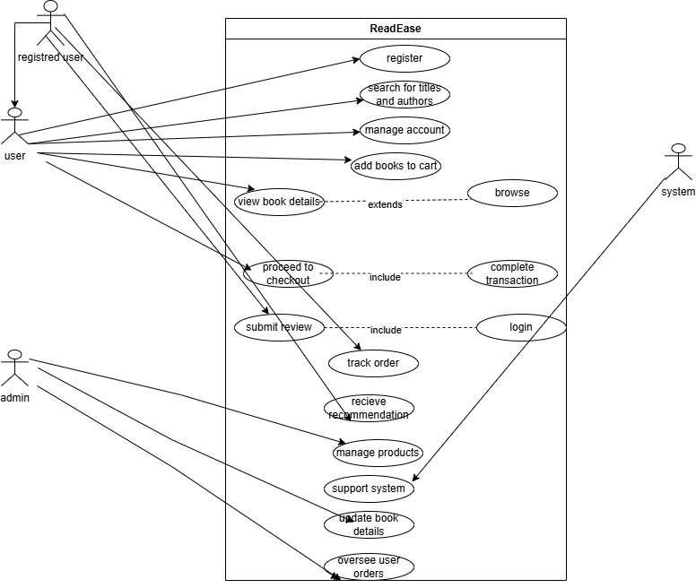

Activity diagram

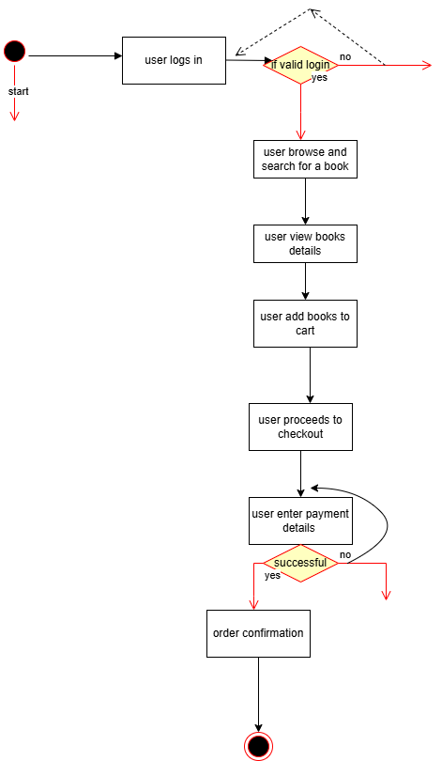

 Class Diagram: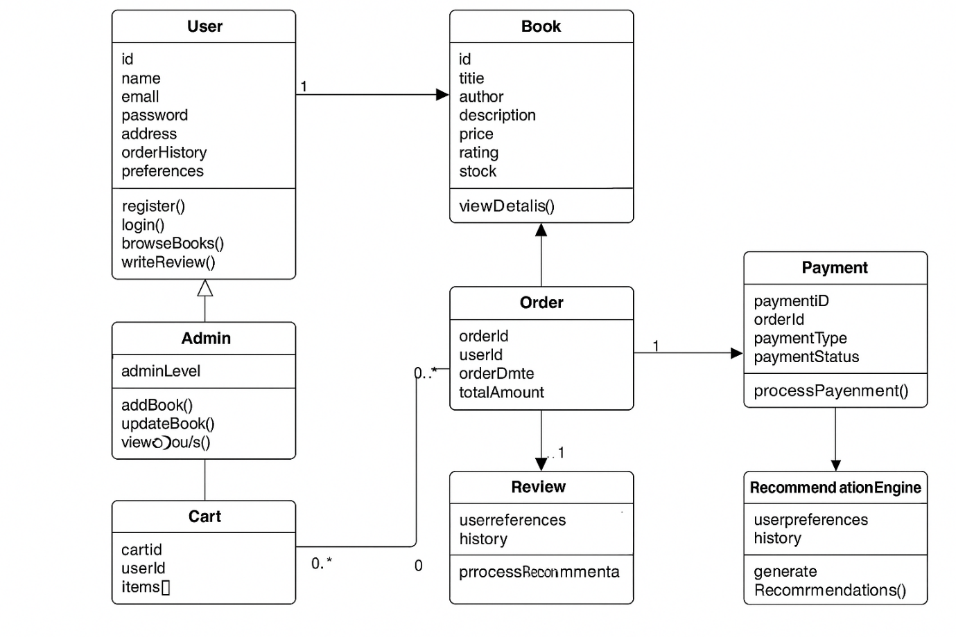

Data Flow Diagram (DFD):

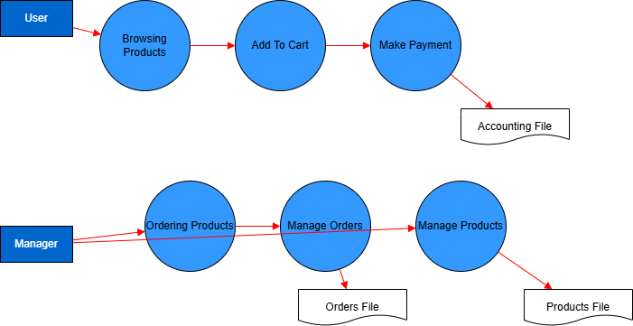

Phase three

***The tasks and subtasks extracted based on the Functional Requirements of our software* :**

**1. User Registration and Login**

**-1.1** User account creation

**-1.2** User login functionality

**-1.3** Password reset/recovery feature

**2. Book Search and Filters**

* **2.1** Search books by:

**-2.1.1** Title

**-2.1.2** Author

**-2.1.3** Type

**-2.1.4** Category

* **2.2** Apply advanced filters for refined results

**3. Book Details**

**3.1** Display book information:

**-3.1.1** Title

**-3.1.2** Author

**-3.1.3** Price

**-3.1.4** Description

**-3.1.5** Reviews

**-3.1.6** Other relevant details

**4. Shopping Cart**

* **4.1** Add books to cart
* **4.2** Remove books from cart
* **4.3** Update quantities or selections in cart
* **4.4** Proceed to checkout

**5. Secure Payment Gateway**

* **5.1** Support for multiple payment methods:

**-5.1.1** Credit Card

**-5.1.2** PayPal

* **5.2** Ensure secure transaction processing

**6. Order Confirmation and Tracking**

**-6.1** Send order confirmation to user

**-6.2** Allow users to track delivery status

**7. User Reviews and Ratings**

**-7.1** Allow users to write reviews

**-7.2** Enable users to rate purchased books

**8. Recommendation System**

**-8.1** Analyze user preferences and history

**-8.2** Display personalized book suggestions

**9. Customer Support**

* **9.1** Provide access to:

**-9.1.1** FAQs

**-9.1.2** Live chat support

**-9.1.3** Email support

**10. Admin Dashboard**

**-10.1** Manage books (CRUD operations)

**-10.2** View and manage customer orders

**-10.3** Update book details (e.g., price, description, stock)

**Software Project Task Table**

|  |  |  |  |  |  |  |  |  |  |
| --- | --- | --- | --- | --- | --- | --- | --- | --- | --- |
| **Task ID** | **Task Name** | **Predecessor Tasks** | **Duration (days)** | **ES** | **EF** | **LS** | **LF** | **Critical Path** | **Slack** |
| **T1** | User Registration and Login | **-** | **3** | **0** | **3** | **0** | **3** | **YES** | **0** |
| **T2** | Book Search and Filters | **-** | **4** | **0** | **4** | **0** | **4** | **YES** | **0** |
| **T3** | Book Details Page | **T2** | **3** | **4** | **7** | **4** | **7** | **YES** | **0** |
| **T4** | Shopping Cart | **T3** | **3** | **7** | **10** | **7** | **10** | **YES** | **0** |
| **T5** | Secure Payment Gateway | **T4** | **2** | **10** | **12** | **10** | **12** | **YES** | **0** |
| **T6** | Order Confirmation & Tracking | **T5** | **2** | **12** | **14** | **12** | **14** | **YES** | **0** |
| **T7** | Reviews and Ratings | **T6** | **2** | **14** | **16** | **14** | **16** | **YES** | **0** |
| **T8** | Recommendation System | **T7** | **3** | **16** | **19** | **16** | **19** | **YES** | **0** |
| **T9** | Customer Support | **-** | **2** | **0** | **2** | **17** | **19** | **YES** | **17** |
| **T10** | Admin Dashboard | **T1,T2** | **3** | **4** | **7** | **19** | **22** | **YES** | **15** |

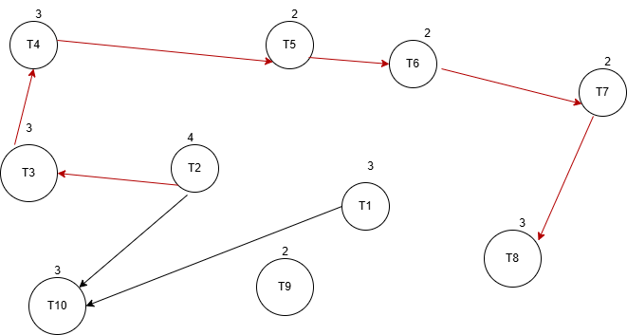

|  |  |  |  |  |
| --- | --- | --- | --- | --- |
| **Task ID** | **Duration (days)** | **Start-day** | **End days** | **notes** |
| **T1** | **3** | **0** | **3** | **Parallel to T2** |
| **T2** | **4** | **0** | **4** | **Critical path** |
| **T3** | **3** | **4** | **7** | **Critical path** |
| **T4** | **3** | **7** | **10** | **Critical path** |
| **T5** | **2** | **10** | **12** | **Critical path** |
| **T6** | **2** | **12** | **14** | **Critical path** |
| **T7** | **2** | **14** | **16** | **Critical path** |
| **T8** | **3** | **16** | **19** | **Critical path** |
| **T9** | **2** | **0** | **2** | **Independent task** |
| **T10** | **3** | **4** | **7** | **After T1 and T2** |

**Phase 4**

